FULL PLOT TREE MAP
Plot ID:___________________ ____ B/C (Circle One) Date: ___/____/______
Burn Unit:_______________________________ Recorders:___________________________
TREATMENT: PREBURN POSTBURN BURN + 1 yr BURN + ____ yr
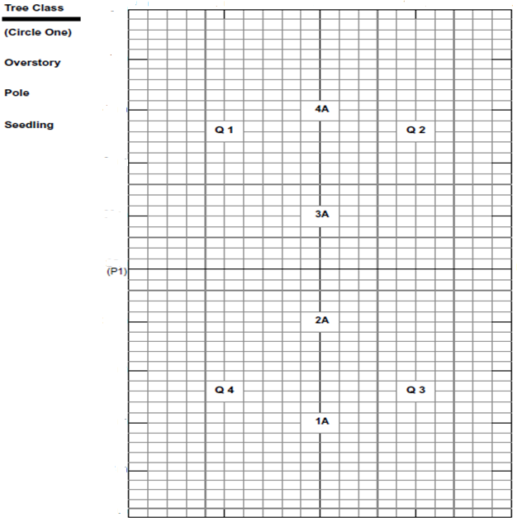

FULL PLOT TREE MAP
Plot ID:___________________ ____ B/C (Circle One) Date: ___/____/______
Burn Unit:_______________________________ Recorders:___________________________
TREATMENT: PREBURN POSTBURN BURN + 1 yr BURN + ____ yr

